User’s Profile

Web Page Art Gallery to view Art

UI/UX Motion Art to Experience

Blog Page contains of Users, Categories and Post Information

Name of website &Main Page of Web Information Post

## User Manual

### User /Admin/Visitor Interface

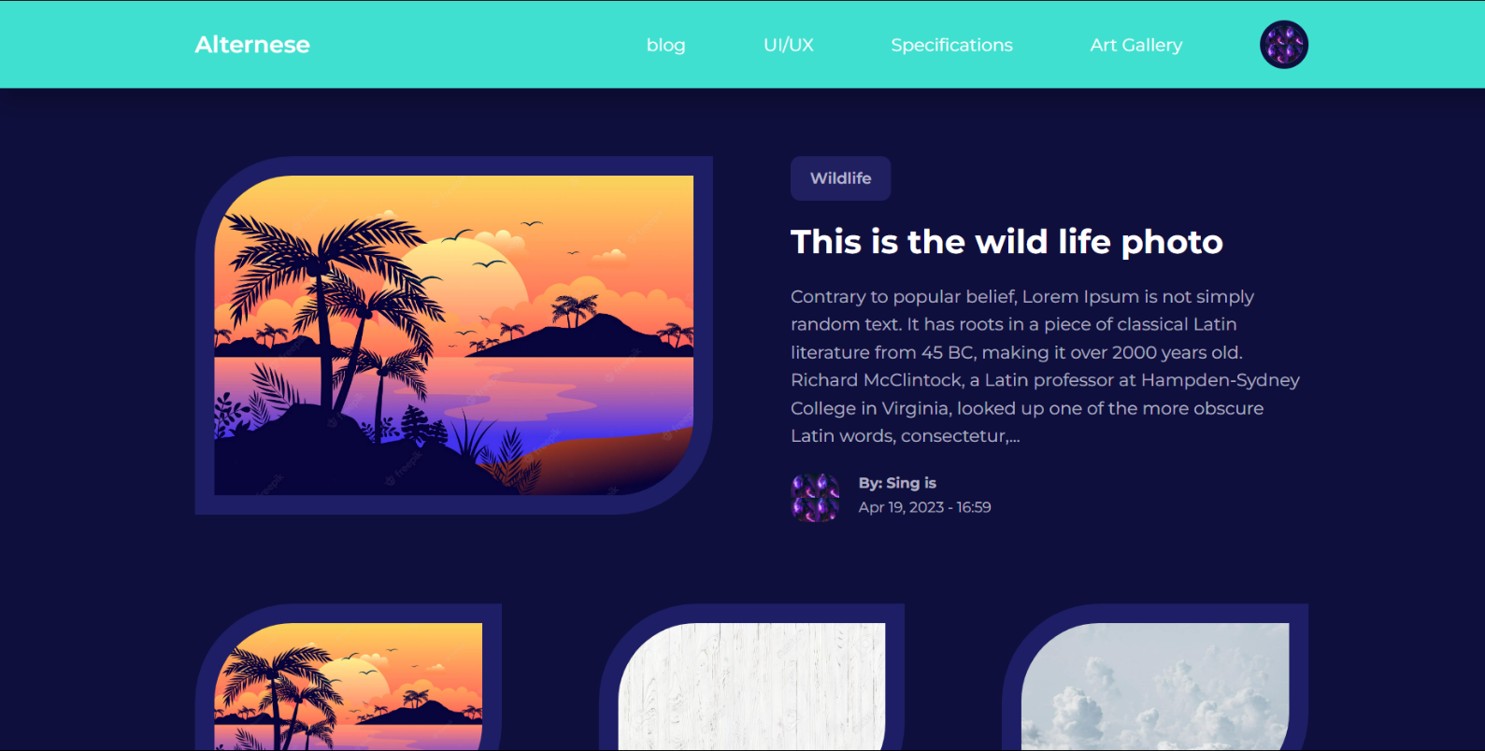

Featured Post of this Website

The Category of uploaded post

The Title and the body of the post

Other Post not Featured

The author of uploaded post

User’s Profile

Web Page Art Gallery to view Art

UI/UX Motion Art to Experience

Blog Page contains of Users, Categories and Post Information

Name of website &Main Page of Web Information Post

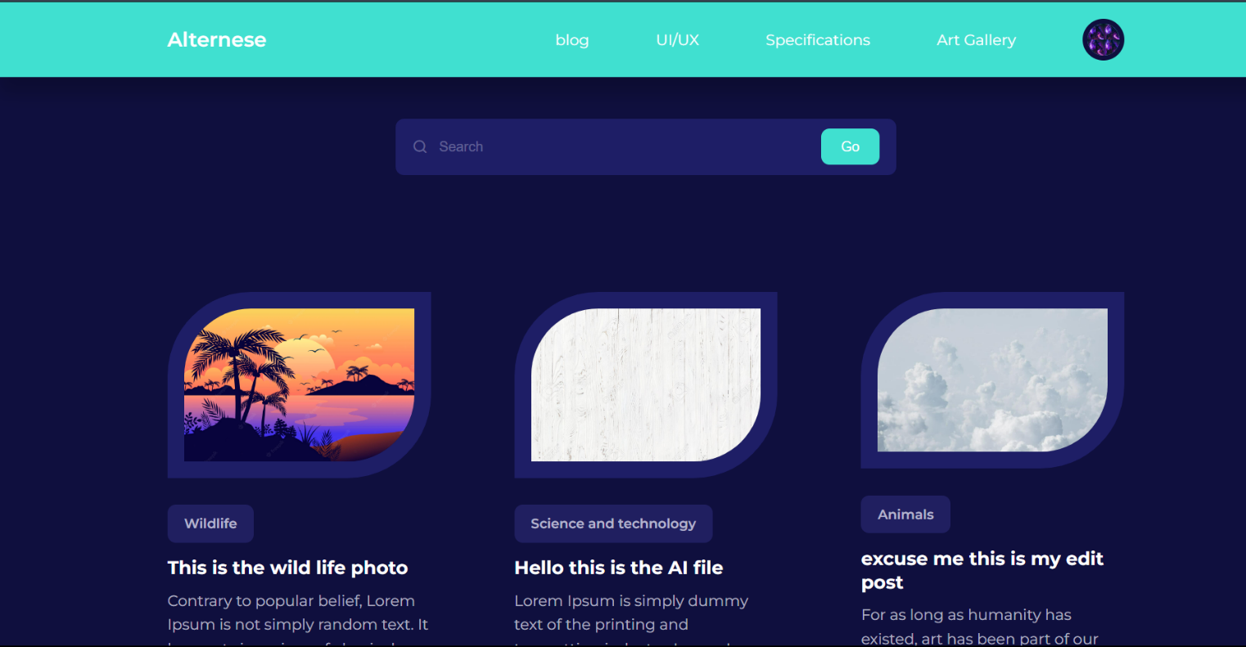

The Go button is to find the word contain in the post

The search bar is used for the visitor/user to search the post easily

Other post uploaded by the users.

Web Page Art Gallery to view Art

UI/UX Motion Art to Experience

Blog Page contains of Users, Categories and Post Information

Name of website &Main Page of Web Information Post

User’s Profile

Solar System revolving art

Blue ring shade fading art

Closing and opening heart art

Butterfly art

Stick balling art

Rectangle roll

Sign fading art

Ring rotational art

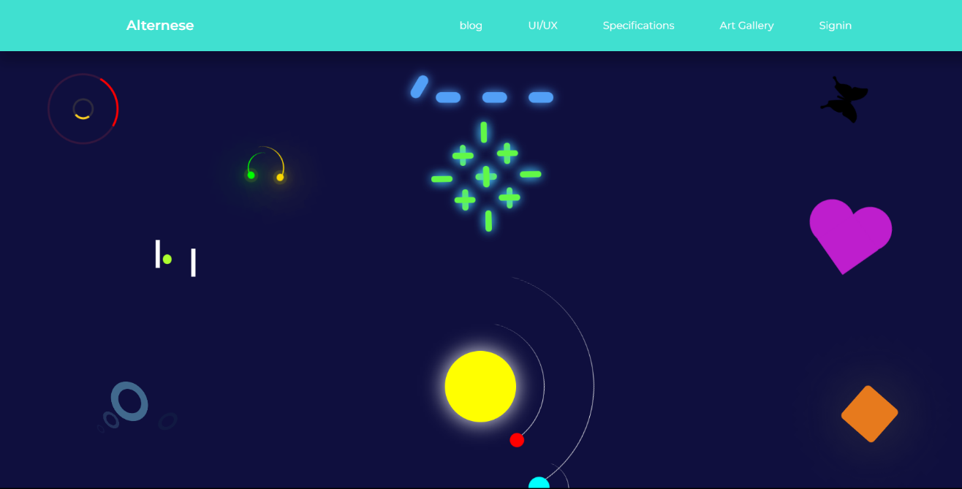

Cyan cube rotating

Ball climbing stairs art

Green Ball bouncing between ring art

Big cube freely moving art

Ocean waving art

Blue and white shade ball rolling

Red bouncing ball



Saturn 360

Dancing sphere

One stick ninja art

White splash art

Black ninja art

Cylinder sea saw ball art

Solar shade art

Mini square shade

Colorful Beyblade art

Rainbow circular art

Wi-Fi Searcher art

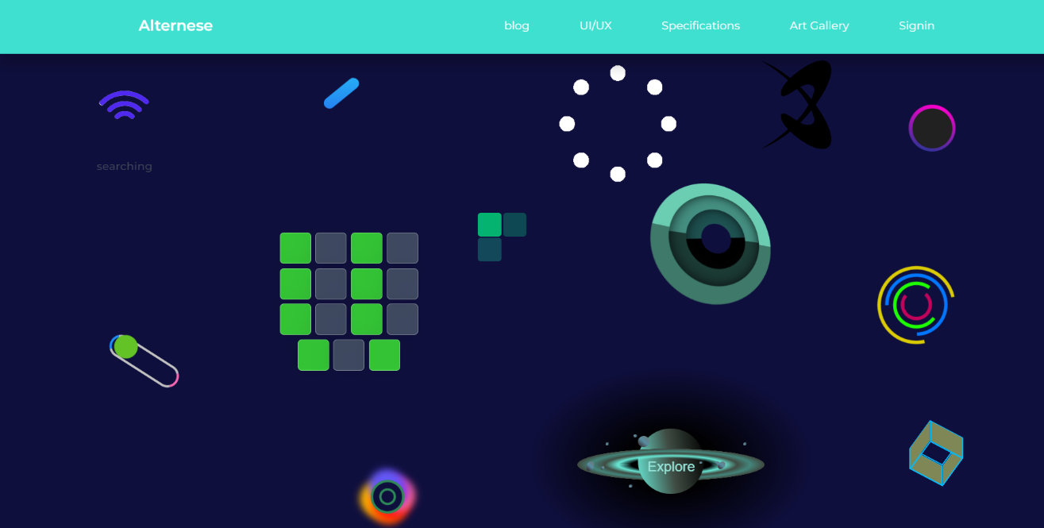

Drawing and removing by pencil

Knife firing art

Planet moving art

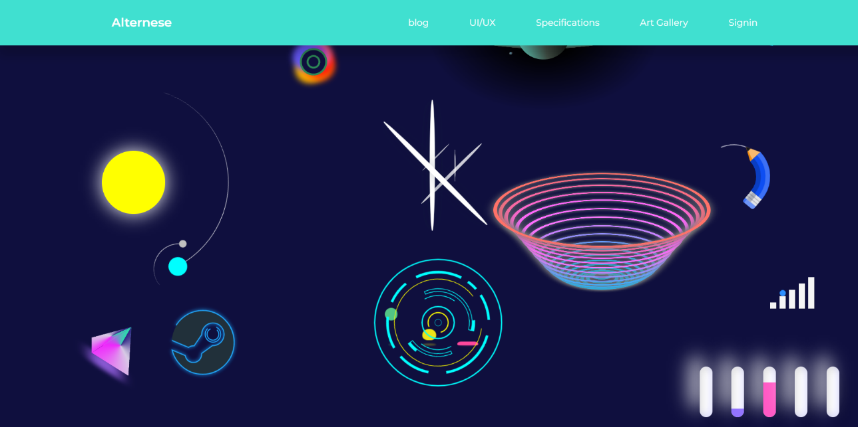

Bouncing/dancing spring

Spaceship art

System art

Prism moving gently art

Tube changing color art

### Sign up page (user manual)



User or Admin have to enter the high security password to sign in

User or admin have to sign in through entering email of username

After the User / Admin is eligible the user can sign in easily

### Sign up page (user manual)

To become a user of this webpage, Enter the First Name

Username is required to sign in back for the users

Email requirement is necessary for the update of news and posts

After the User / Admin is eligible the user can sign in easily

Confirmation password is need for the new user to become the part of this webpage

New User must enter the password for the privacy issues.

To become a user of you need to fill the last name

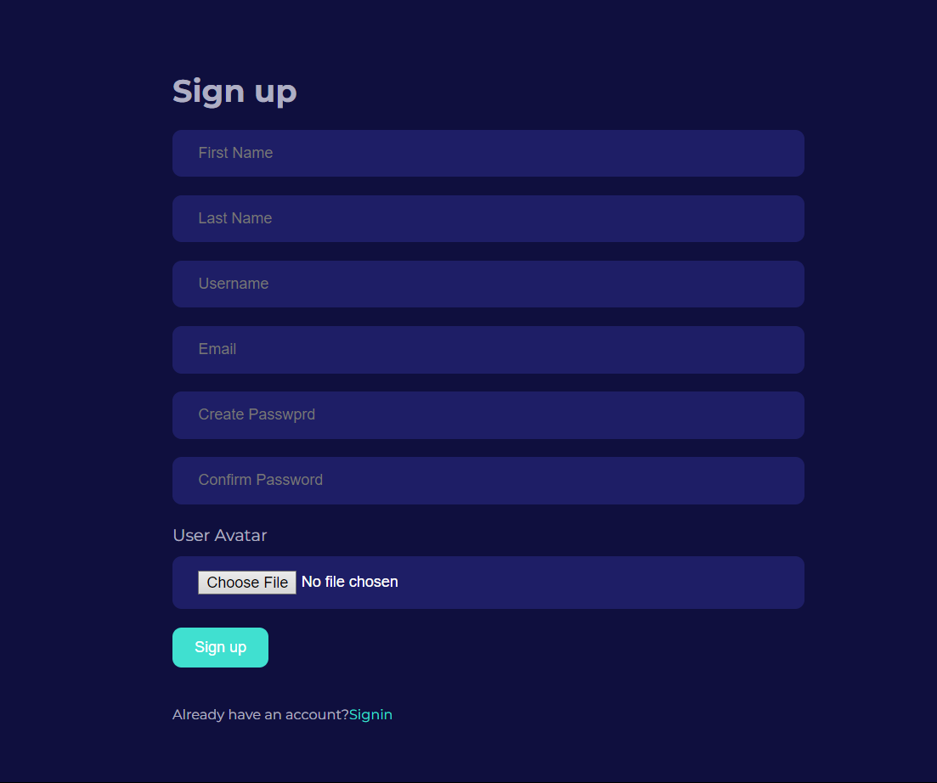

After the all the required information by the system the new user can click signup to be part of the system

## Admin Manual

Admin can edit post in the edit post page by clicking this

Admin can Delete the post easily through this button

### Manage Post

Admin can add different category through this section

This is Admin Add Post Section to Add Post

Admin can manage the post through this section

Admin can manage user through this section

Admin can add new user through this section

Admin can Manage Different Category through this section

### Add Post

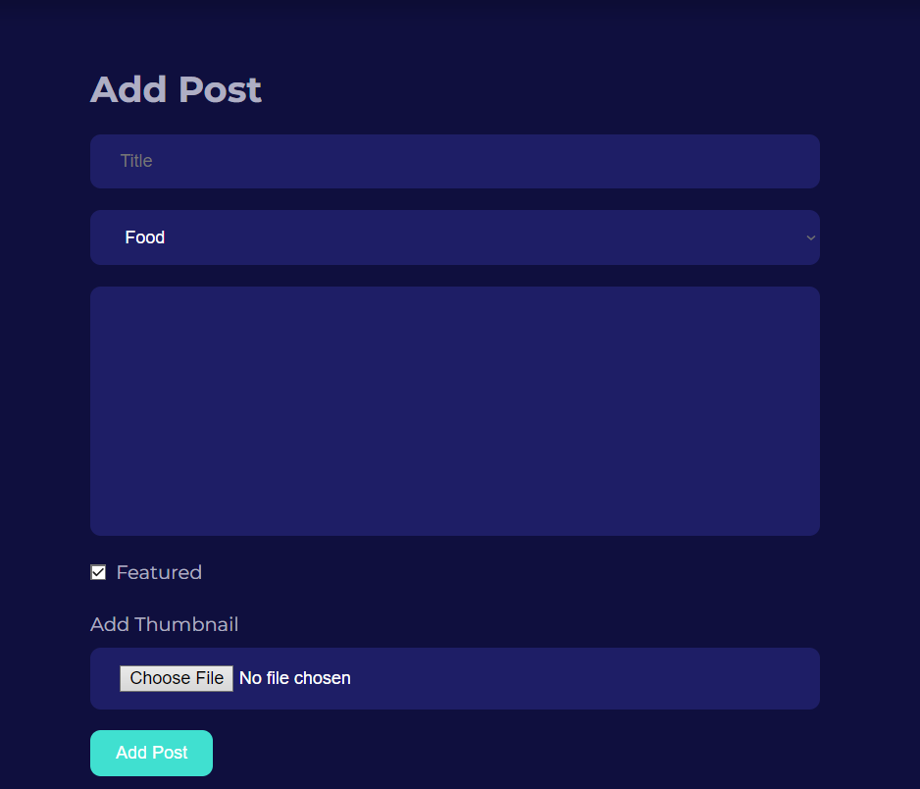

Admin can fill the title of the post

Admin can select the category by drop down menu

Admin can choose file from the device such as laptop or PC

Admin has to fill the information of the title for the post content

Admin can feature post through this

Admin Can Add Post after filling required information given above

### Edit Post

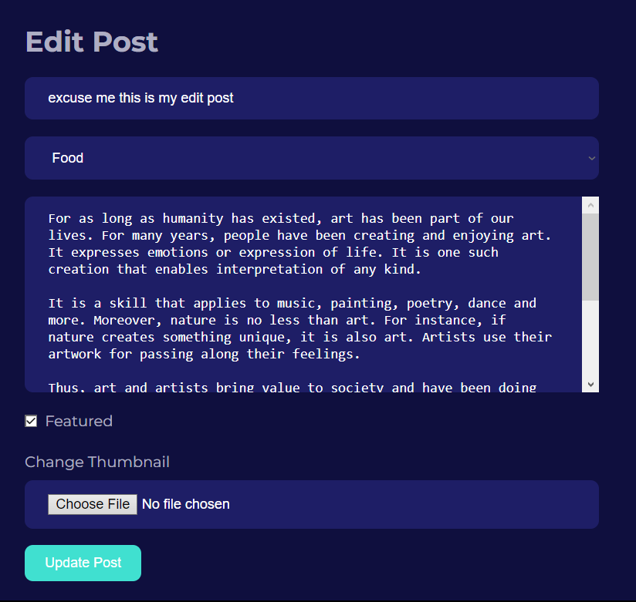

Admin can fill the title of the post

Admin can select the category by drop down menu

Admin can choose file from the device such as laptop or PC

Admin has to fill the information of the title for the post content

Admin can feature post through this

Admin Can Add Post after filling required information given above

### Add User

To add a new user of this webpage, Enter the First Name

Last name has to be filled for the new user registration

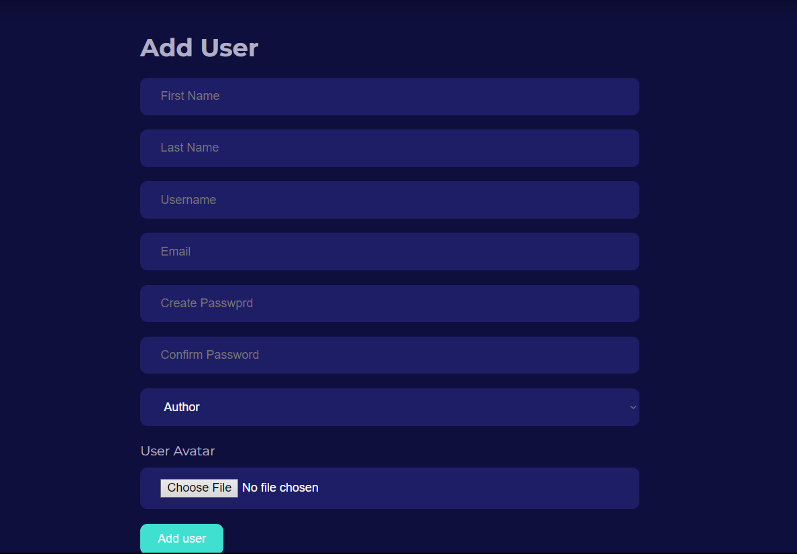

Confirmation password is need for new user to become the part of this webpage

Username is required for registration to sign in back for the users

To Add user Admin must enter the password for the privacy issues.

Email requirement is necessary for the update of news and posts

After the User / Admin is eligible the user can sign in easily

### Edit User

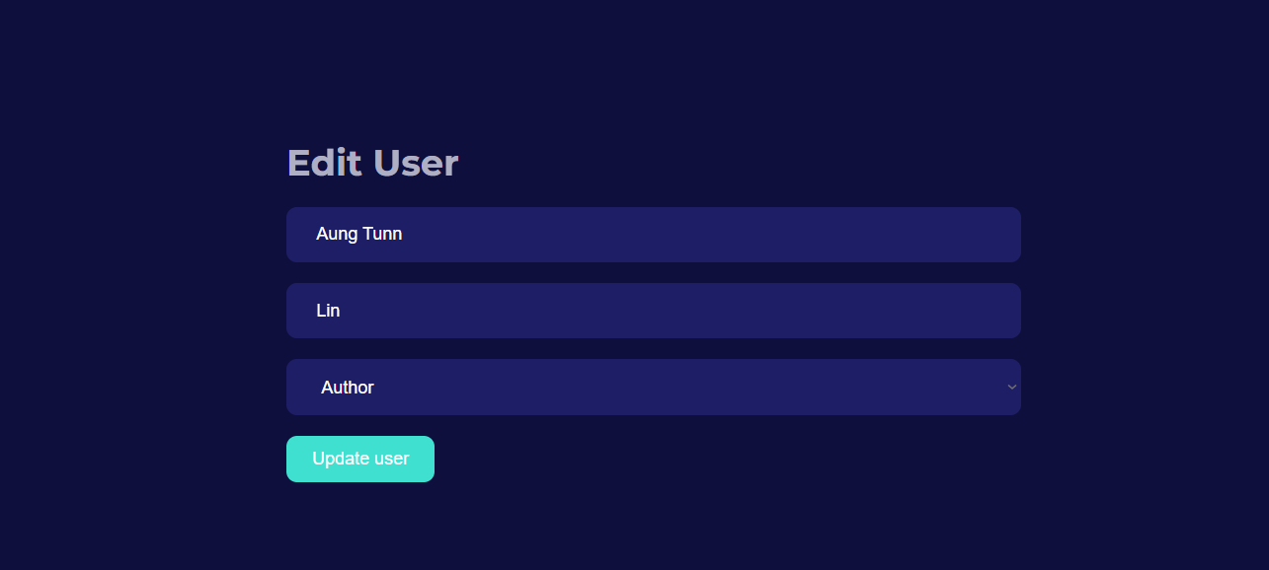

Last Name is need to Edit the user

Admin Can Update the User after fulfilling the requirements on above.

First name is also need to Edit user

Admin has right to change the Authority of the user and the admin

### Delete User

Admin can go to Edit Page by clicking the edit button

To Delete the user the admin has to just click the delete button to delete the user

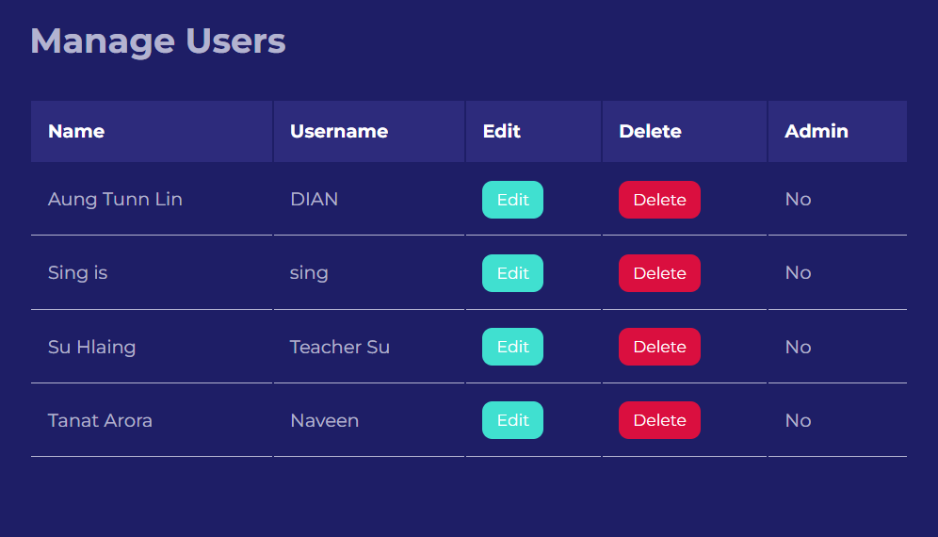

The Data Information of the user

### Add Category

### 

### 

Admin can Add Category of the Title for the post

Admin have to write the Description related on the topic of Category

Admin can Add easily to Add category after filling the correct form.

### Edit Category

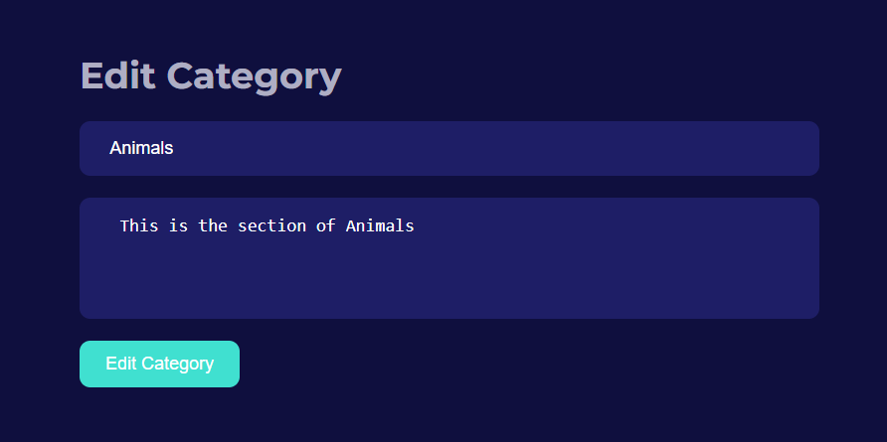

Admin have to edit the Description related on the topic of Category

Admin can Edit easily to Edit category after filling the correct form.

Admin can delete the Category Title just by clicking the Delete Button

Admin can go to Edit Category Page by clicking the Edit Button

### Delete Category

The Title of the Category Post

